KV4 - Izrada konačne vizualizacije podataka

Implementacija osnovnih funkcionalnosti
    - Dovršiti implementaciju koda za nedostajuće osnovne funkcionalnosti.
Padajuci izbornik:
<select id="religion-select"></select>

select
.selectAll("option")
.data(religionList)
.enter()
.append("option")
.attr("value", d => d)
.text(d => d);
select.property("value", "Select religion");

export const religionList = ["Select religion", ...religionKeysOrdered.map(key => columnMapping[key])];

export const religionKeysOrdered = [
"chrstprot",
"chrstcat",
"chrstorth",
"chrstang",
"chrstothr",
"chrstgen",
"judorth",
// ...

export const columnMapping = {
chrstprot: "Christianity Protestants",
chrstcat: "Christianity Roman Catholics",
chrstorth: "Christianity Eastern Orthodox",
chrstang: "Christianity Anglican",
chrstothr: "Christianity Others",
chrstgen: "Christianity Total",
judorth: "Judaism Orthodox",
// ...

Izbornik za lakse snalazenje na stranici:
<div class="menu">
<div>
<a href="#section1">Country division</a>
</div>
<div>
<a href="#section2">Regional division</a>
</div>
<div>
<a href="#section3">Religion distribution</a>
</div>
<div>
<a href="#" id="show-data-btn">Global data</a>
</div>
</div>
Gumb za resetiranje pogleda na kartu:
<button id="reset-btn-countries" style="display:none;">Back to World View</button>

const resetBtnCountries = d3.select("#reset-btn-countries");

resetBtnCountries.on("click", function(event, d) {
resetBtn(zoomGroup, resetBtnCountries, infoBoxCountries);
resetGraph(chartSvgCountries)
});

function resetBtn(zoomGroup, resetBtnCountries, infoBoxCountries) {
zoomGroup.transition().duration(750).attr("transform", ""); // Reset transform
resetBtnCountries.style("display", "none");
infoBoxCountries.text("Select a country");
selectedCountryCode = null;
selectedCountryName = null;
}

Sekcije stranice zbog preglednosti:

<section id="section1">
<h2 style="text-align: center;">Religion division by countries</h2>
<div class="section1-container" style="display: flex; justify-content: space-between;">
<div class="map-container">
<div id="info-box-countries">Select a country</div>
<svg id="map-countries" style="border: 2px solid #999;"></svg>
<button id="reset-btn-countries" style="display:none;">Back to World View</button>
</div>
<div class="graph-container">
<h3 style="text-align: center;">Country Data Visualization</h3>
<svg id="graph-countries"></svg>
</div>
</div>
</section>

<section id="section2">
<h2 style="text-align: center;">Religion division by continents</h2>
<div class="section2-container" style="display: flex; justify-content: space-between;">
<div class="graph-container graph-container-continents">
<h3 style="text-align: center;">Continent Data Visualization</h3>
<svg id="graph-continents"></svg>
</div>
<div class="map-container">
<div id="info-box-continents">Select a continent</div>
<svg id="map-continents" style="border: 2px solid #999;"></svg>
</div>
</div>

</section>

<section id="section3">
<h2 style="text-align: center;">Religion distribution in world</h2>
<div class="religion-dropdown-container" style="text-align: center; margin-top: 10px;">
<label for="religion-select">Select Religion:</label>
<select id="religion-select"></select>
</div>
<div class="section3-container" style="display: flex; justify-content: space-between;">
<div class="map-container-distribution">
<svg id="map-countries-distribution" style="border: 2px solid #999;"></svg>
</div>
</div>
</section>
</div>

    - Testirati osnovne funkcionalnosti i osigurati da su ispravne, tj. da funkcioniraju na očekivani način. Potrebno potvrditi slikom.
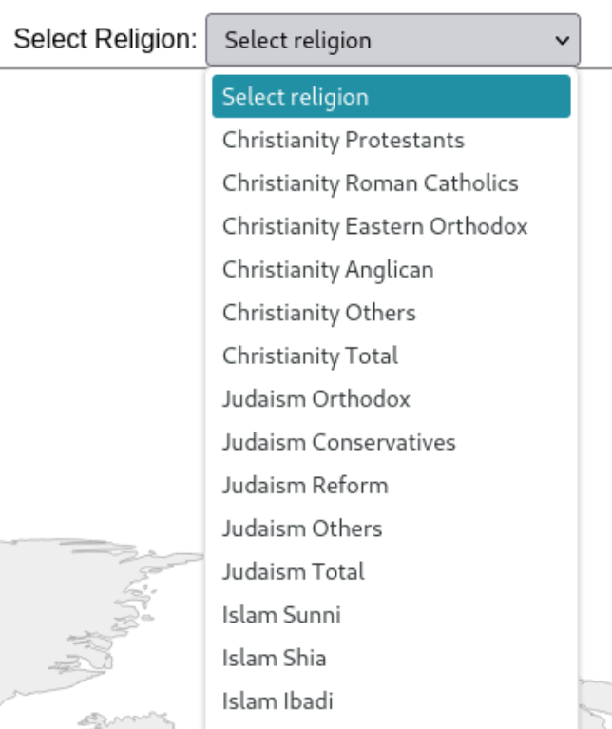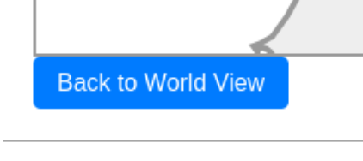

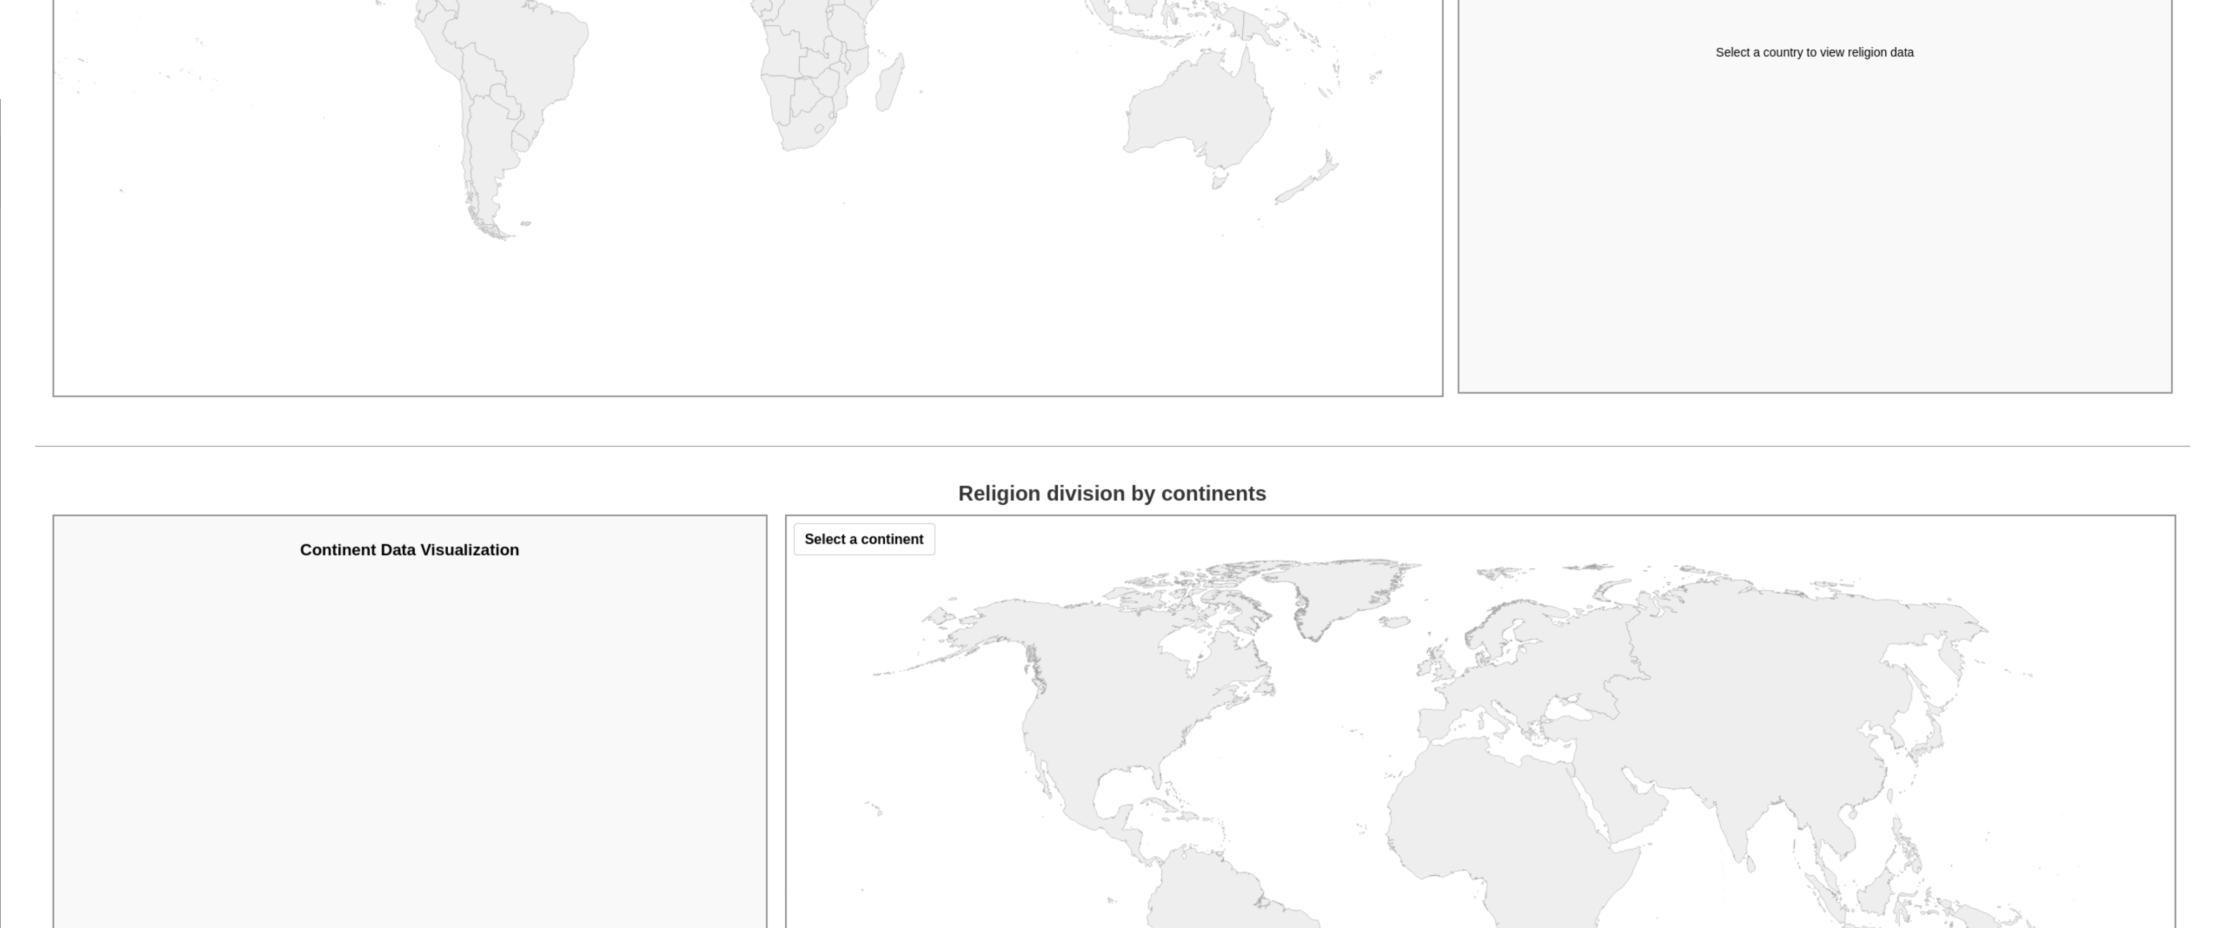

Implementacija osnovnog ponašanja
    - Dovršiti implementaciju koda za nedostajuće osnovne interakcije.
Zoomiranje na klik
function processClickNationalEvent(event, d, infoBoxCountries, resetBtnCountries, zoomGroup, width, height, slider) {
console.info("Clicked on country:", d.properties.name);
const pathElement = d3.select(event.currentTarget);
const bbox = pathElement.node().getBBox(); // Get the SVG bounding box in pixel space

const { x, y, width: bboxWidth, height: bboxHeight } = bbox;
if (bboxWidth === 0 || bboxHeight === 0) {
return;
}

const scale = Math.min(8, 0.9 / Math.max(bboxWidth / width, bboxHeight / height));
const centerX = x + bboxWidth / 2;
const centerY = y + bboxHeight / 2;
const translate = [width / 2 - scale * centerX, height / 2 - scale * centerY];
// Apply transform to zoomGroup
zoomGroup.transition()
.duration(750)
.attr("transform", `translate(${translate}) scale(${scale})`)
const year = slider.node().value;
const countryName = d.properties.name || "Unknown Country";
const countryCode = getCountryCode(countryName, year);
const displayName = getDisplayName(countryName, year);
selectedCountryCode = countryCode;
selectedCountryName = displayName;
displayNationalData(countryCode, displayName);
drawGraph(countryCode, year);
resetBtnCountries.style("display", "block");
}
promjena godine prilikom koristenja slidera (plus ostale stvari)
slider.on("input", function () {
const year = this.value;
yearDisplay.text("Year: " + year); // ova linija koda
if (selectedCountryCode && selectedCountryName) {
drawGraph(selectedCountryCode, year);
displayNationalData(selectedCountryCode, selectedCountryName, year);
} else if(selectedReligionDistribution) {
updateCountryColors(nationalData, selectedReligionDistribution, slider.node().value);
} else if(selectedRegions) {
displayRegionalData(selectedRegions, infoBoxContinents);
drawRegionalGraph(selectedRegions, slider.node().value);
} else{
console.warn("NO COUNTRY SELECTED, SKIPPING GRAPH AND INFOBOX UPDATE");
}
});

Promjena odabrane religije
select.on("change", function() {
const religionKey = this.value;
console.log("Religion selected:", religionKey);
if (religionKey && religionKey !== "Select religion") {
selectedReligionDistribution = religionKey;
updateCountryColors(nationalData, religionKey, slider.node().value);
} else {
resetMapColors();
}
})

    - Testirati osnovno ponašanje i osigurati da je ispravno, tj. da funkcionira na očekivani način. Potrebno potvrditi slikom.
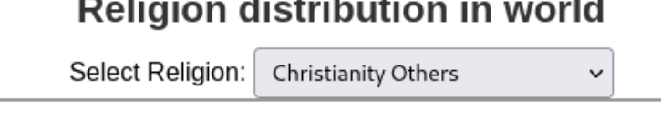
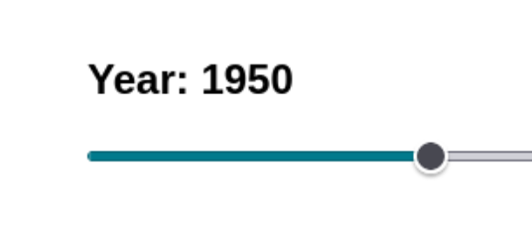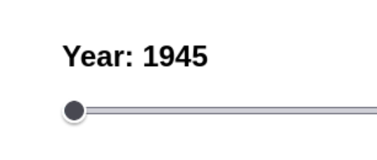

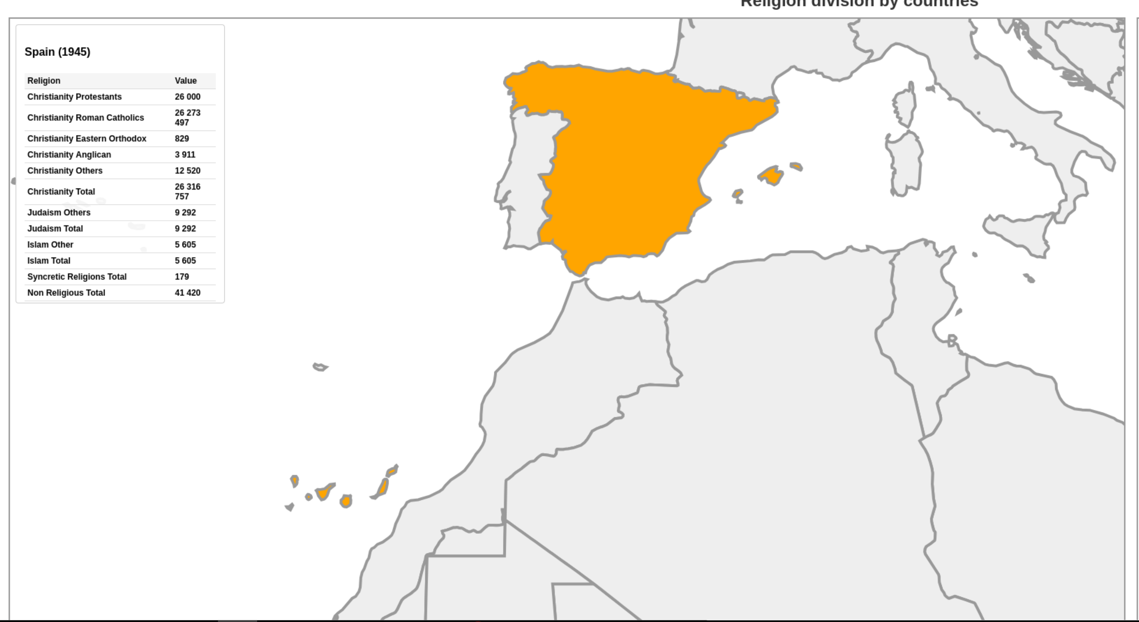
Ili

Implementacija naprednih funkcionalnosti
    - Identificirati napredne funkcionalnosti koje će biti implementirane.
Prikaz stupcastog graf-a za odabrane podatke
Bojanje karte s obzirom na gustocu religija
Prikaz podataka o drzavi u kutu, moguce scrollanje
    - Implementirati napredne funkcionalnosti. Dokazati opisom primjera koda.
    - Testirati napredne funkcionalnosti i osigurati da su ispravne, tj. da funkcioniraju na očekivani način. Potrebno potvrditi slikom.

Implementacija naprednog ponašanja
    - Identificirati napredna ponašanja koje će biti implementirana.
Prelazak preko stupcastog grafa prikazuje podatke za taj stupac
Prelazak preko karte pokazuje podatke za tu drzavu
Prelazak preko karte mijenja ime drzave
    - Implementirati napredna ponašanja. Dokazati opisom primjera koda.
    - Testirati napredno ponašanje i osigurati da je ispravno, tj. da funkcionira na očekivani način. Potrebno potvrditi slikom.

